**SE4050 – DL**

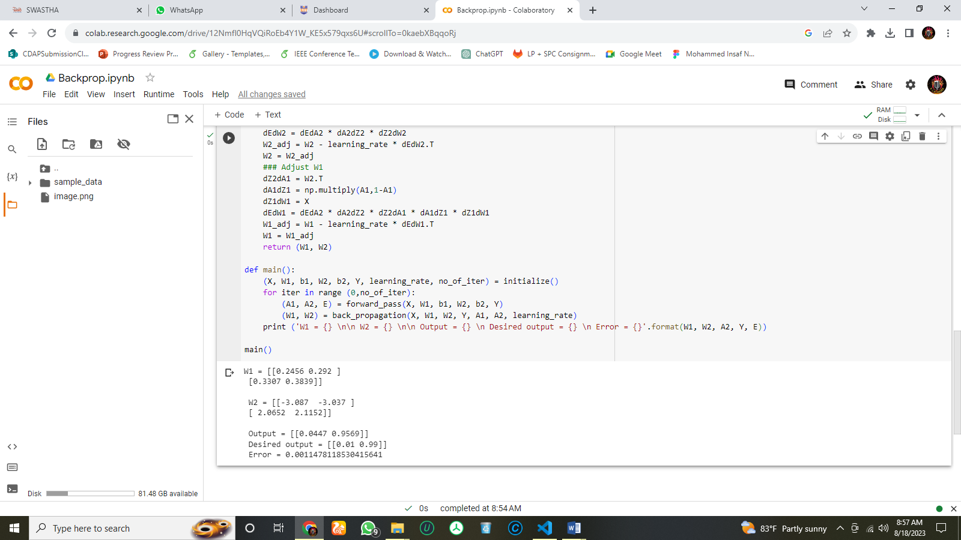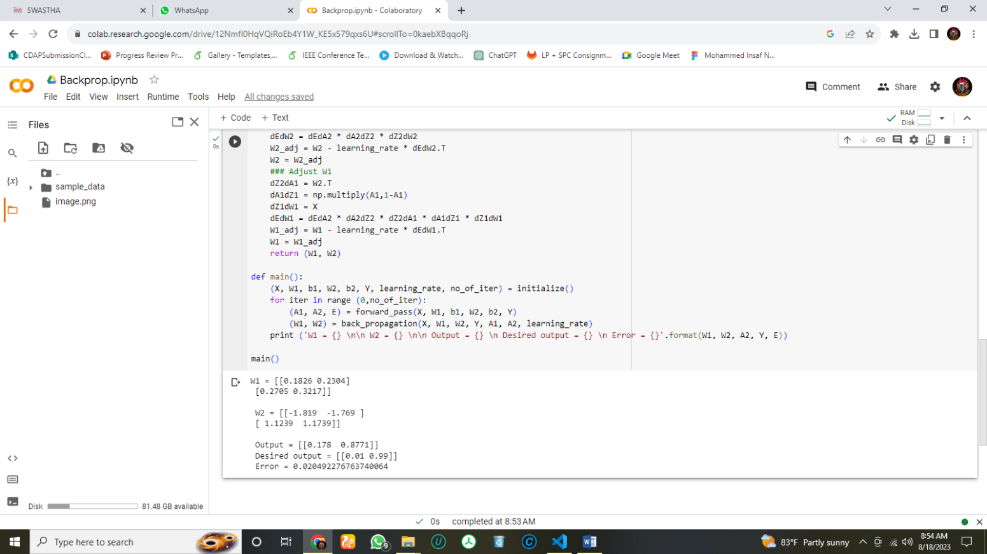**Lab 1**

Figure 2: After 1000th Iteration

Figure 1: After 100 Iteration

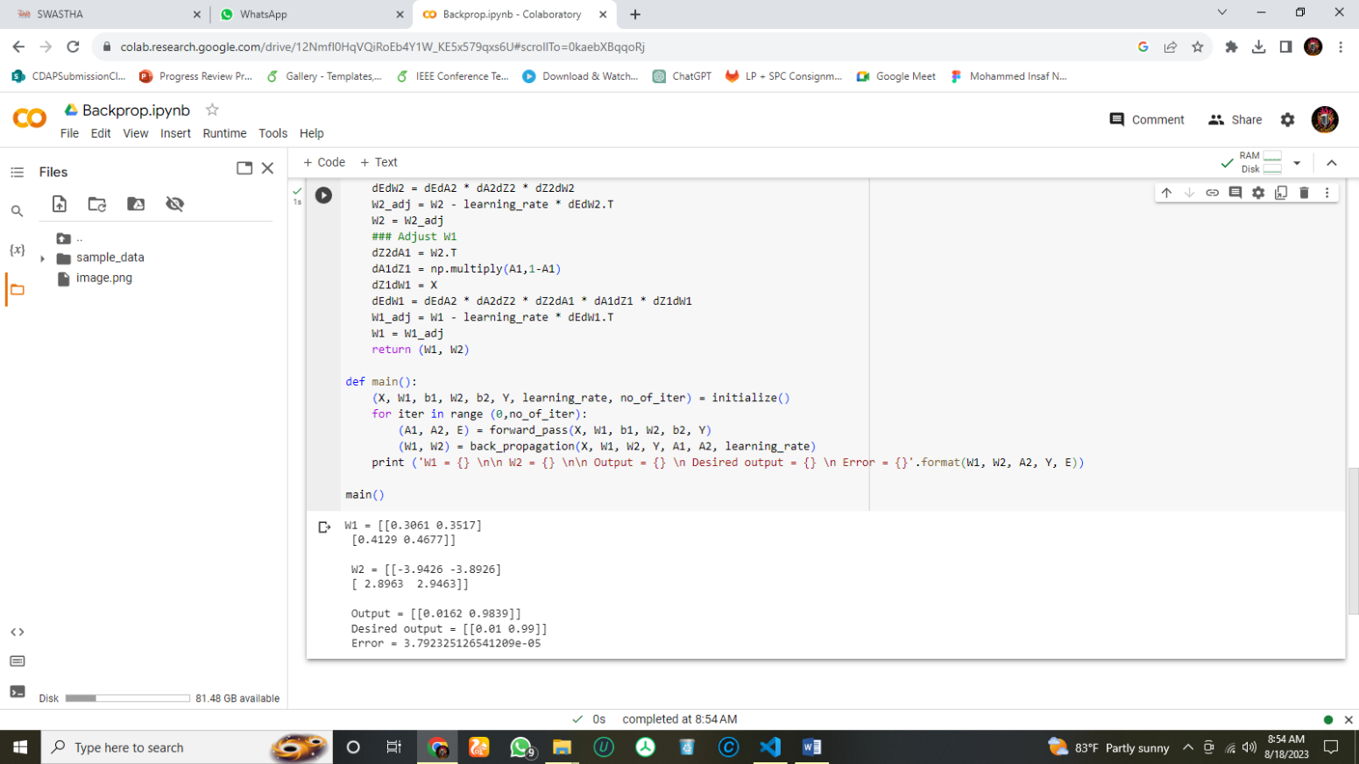A noteworthy observation is that the accuracy of a neural network improves progressively as the number of training epoch’s increases. This can be seen in the gradual convergence of the network's output towards the desired output. Additionally, the calculated error between the network's output and the desired output consistently decreases with each increase in the number of epochs. This trend holds true across different epoch settings, such as 100, 1000, and 10000 epochs. This behavior is expected, as extended training epochs allow the network to refine its internal parameters and better approximate the desired output. This results in reduced error and improved accuracy. However, it is important to note that the accuracy of a neural network does not always improve with the number of epochs. In some cases, the network may start to over fit the training data, which can lead to a decrease in accuracy on new data. Therefore, it is important to monitor the accuracy of the network on a validation set as the number of epoch’s increases. If the accuracy on the validation set starts to decrease, then it is time to stop training the network.

Figure 3: After 10000th Iteration